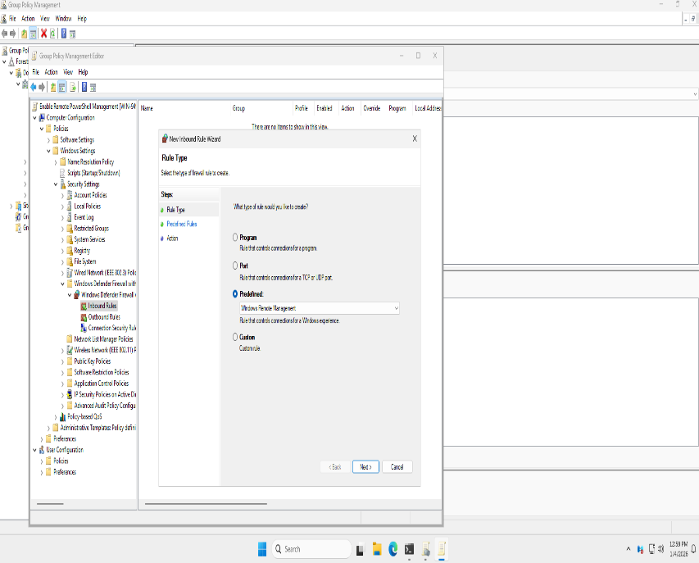
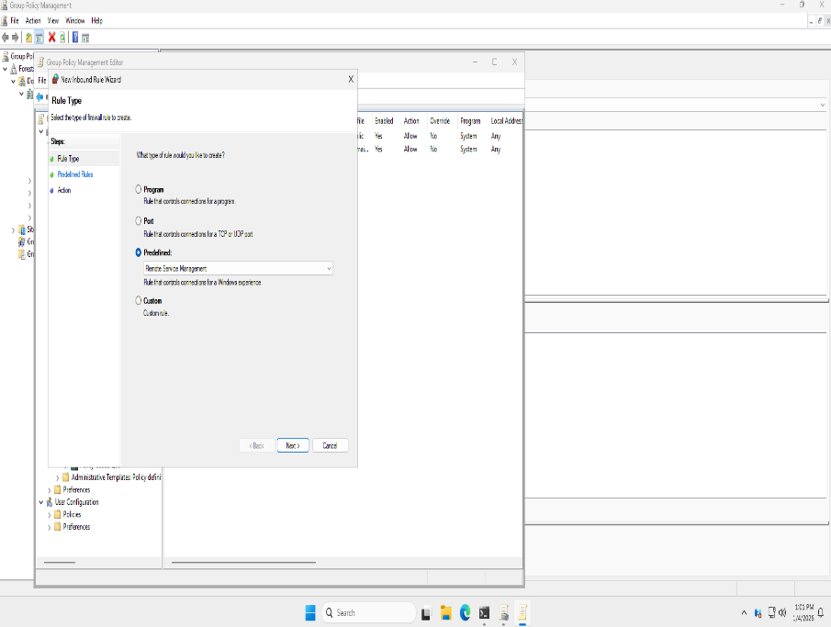
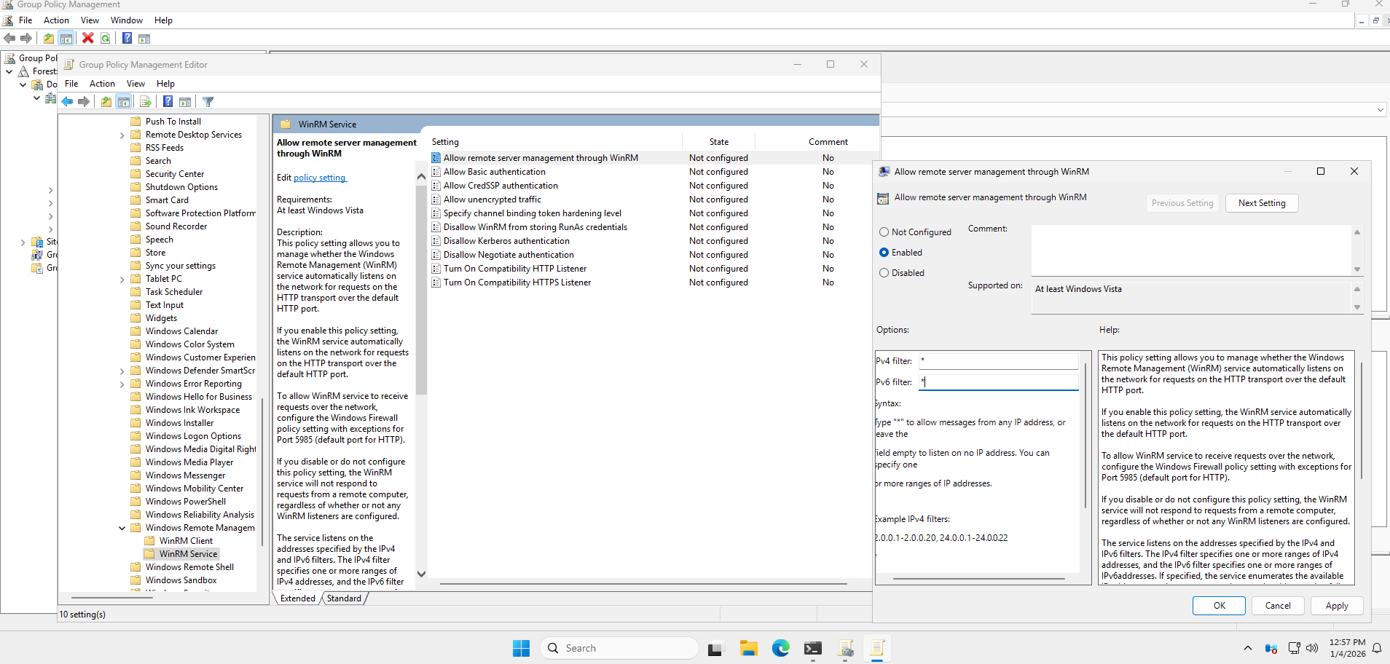
Remote Monitoring and Management with PowerShell
A Group Policy Object (GPO) was created to enable remote PowerShell management.
An inbound firewall rule was created to allow Windows Remote Management (WinRM) and Remote Service Management.
Created an inbound firewall rule for windows remote management and Remote service management
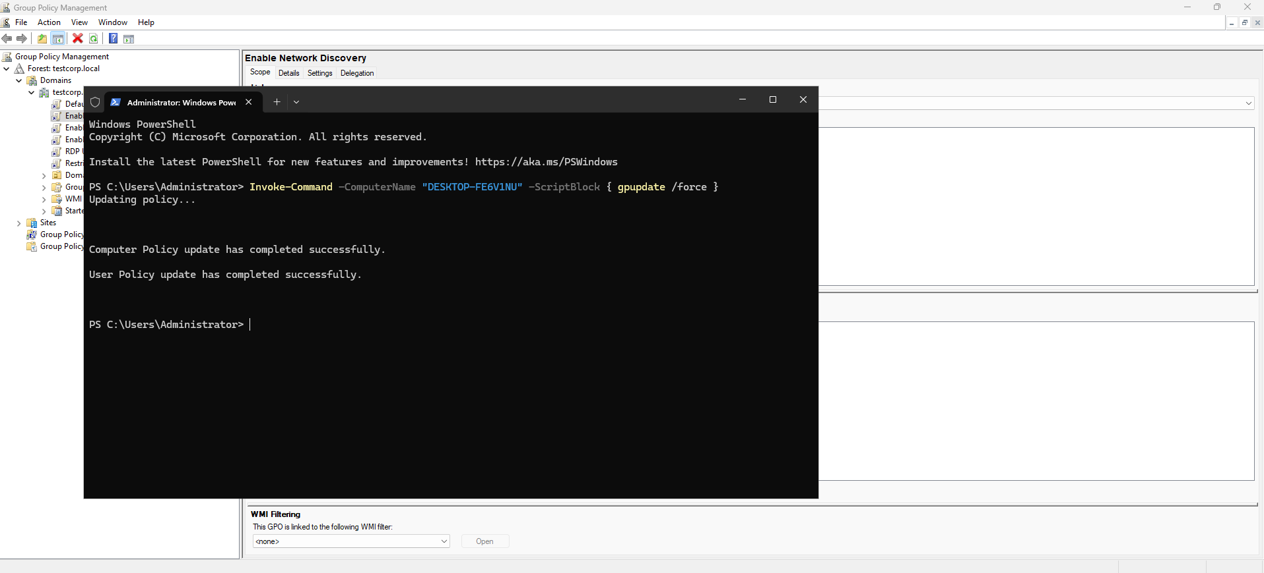
Remote Management Verification
With these configurations in place, the workstation can now be managed remotely. PowerShell commands were successfully executed remotely to retrieve system information, including running processes.
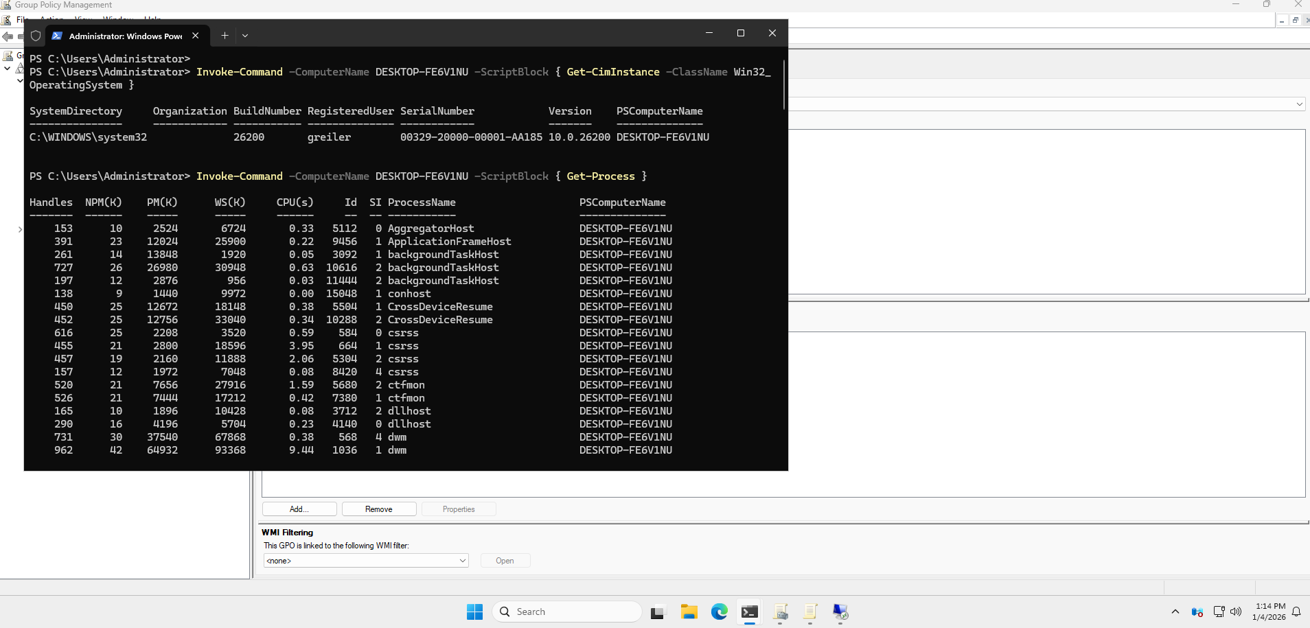
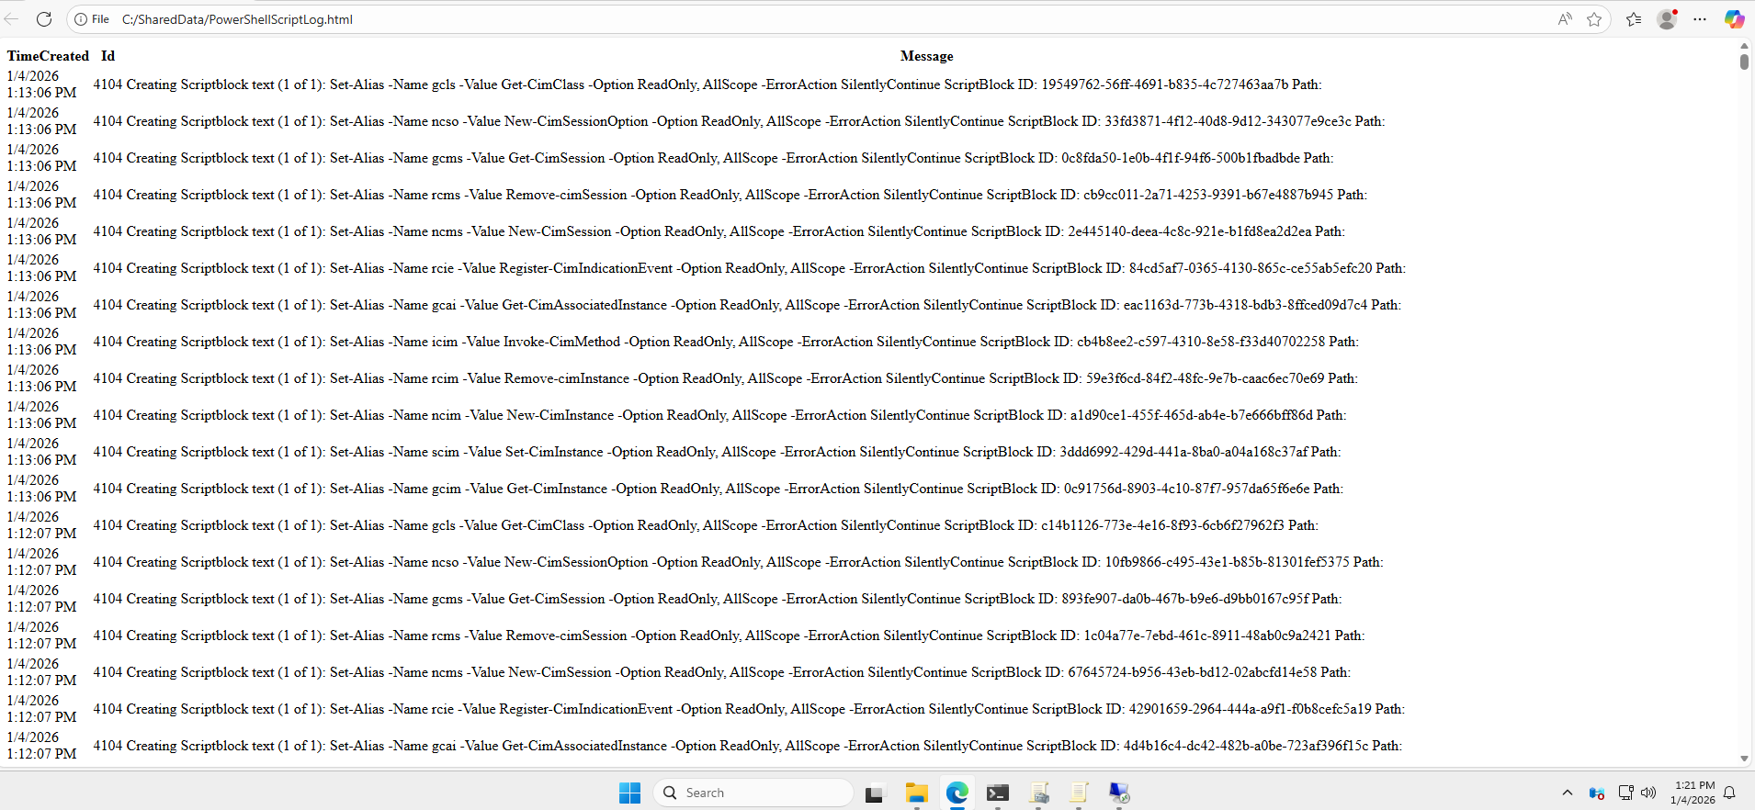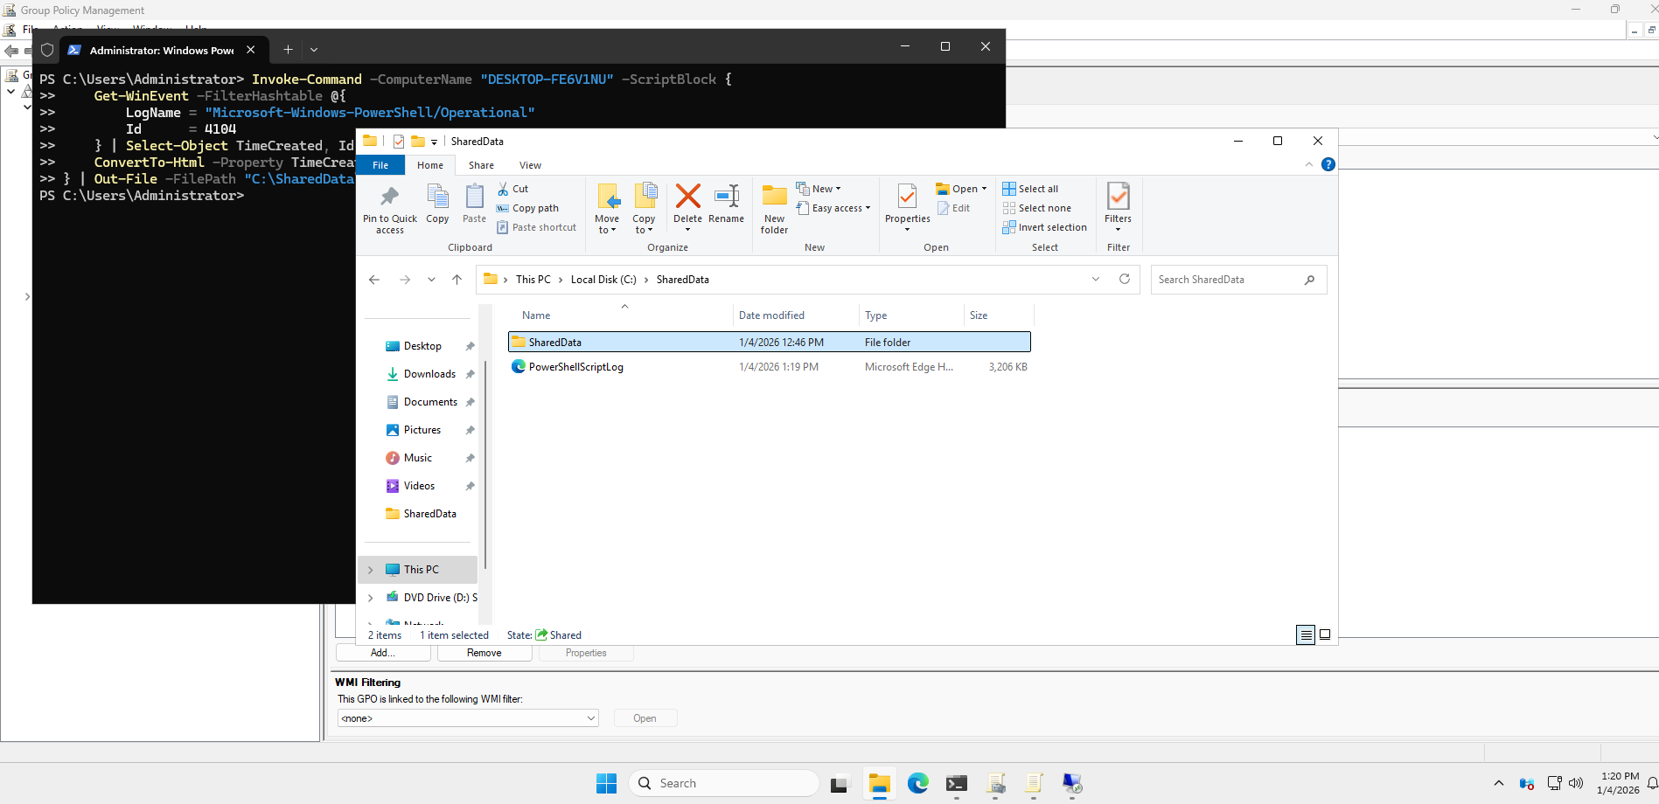
PowerShell Event Log Collection
A PowerShell script was used to retrieve PowerShell script execution start events (Event ID 4104) from the workstation and export them to an HTML file.
PowerShell command used:
Invoke-Command -ComputerName "DESKTOP-FE6V1NU" -ScriptBlock {

Get-WinEvent -FilterHashtable @{
LogName = "Microsoft-Windows-PowerShell/Operational"
Id = 4104
} | Select-Object TimeCreated, Id, Message |
ConvertTo-Html -Property TimeCreated, Id, Message -Title "PowerShell Script Execution Log"

} | Out-File -FilePath "C:\SharedData\PowerShellScriptLog.html"
This confirms that remote PowerShell management is enabled and that PowerShell script execution events can be collected and reviewed remotely.
Get-WinEvent -FilterHashtable @{
LogName = "Microsoft-Windows-PowerShell/Operational"
Id = 4104
} | Select-Object TimeCreated, Id, Message |
ConvertTo-Html -Property TimeCreated, Id, Message -Title "PowerShell Script Execution Log"
} | Out-File -FilePath "C:\SharedData\PowerShellScriptLog.html"

